A Project Report On

**GameToh online Food Ordering System**

Submitted in partial fulfillment of the requirement for the award of the degree

MASTER OF COMPUTER APPLICATIONS (INTEGRATED)

from

Gujarat Technological University



Academic Year 2020 – 2021

**Akash Trivedi (175220686001)**

|  |
| --- |
| **Internal Guide** |
| Prof. Vivek Gondalia |



Marwadi Education Foundation’s Group of Institutions

(MEFGI)

Rajkot-Morbi Road, At & PO: Gauridad, Rajkot 360003, Gujarat, India.



**Faculty of Computer Applications (FCA)**



**This is to certify that the project work entitled**

**GameToh Food Ordering System**

**submitted in partial fulfillment of the requirement for**

**the award of the degree of**

**Master of Computer Applications (Integrated)**

**of the**

**Gujarat Technological University**

**is a result of the bonafide work carried out by**

**Akash Trivedi (175220686001)**

**during the academic year 2020 - 2021**

|  |  |  |  |  |
| --- | --- | --- | --- | --- |
| **Faculty Guide** |  |  |  | **HOD** |

**External Viva**

|  |  |  |
| --- | --- | --- |
| **Name of the Examiners** |  | **Signature with Date** |

**CERTIFICATE**

(Attach the college certificate that is available at the college store)

# DECLARATION

We hereby declare that this project work entitled **GameToh Food Ordering System** is a record done by us.

We also declare that the matter embodied in this project is genuine work done by us and has not been submitted whether to this University or to any other University / Institute for the fulfillment of the requirement of any course of study.

Place:

Date:

Akash Trivedi (175220686001) **Signature: _________**

# ACKNOWLEDGEMENT

It is indeed a great pleasure to express our thanks and gratitude to all those who helped us. No serious and lasting achievement or success one can ever achieve without the help of friendly guidance and co-operation of so many people involved in the work.

We are very thankful to our guide Prof. Vivek Gondaliya and also to Prof. Dimple Chauhan for her insightful direction**. T**he person who makes us to follow the right steps during a project work. We express our deep sense of gratitude to her for her guidance, suggestions and expertise at every stage. A part from that her valuable and expertise suggestion during documentation of my report indeed help us a lot.

Thanks to our friends and colleagues who have been a source of inspiration and motivation that helped to us with new ideas during our project work.

We would heartily thankful to Head and Dean of our department **Dr. Sunil Bajeja and Dr. R. Sridaran** to give us an opportunity to work over this report and for their end-less and great support. And to all other people who directly or indirectly supported and help us to fulfil our task.

Akash Trivedi (175220686001) **Signature: _________**

# Table of Contents

|  |  |  |
| --- | --- | --- |
| **Chapters** | **Particulars** | **Page No.** |
| 1 | **SYNOPSIS** | 1 |
| 2  2.1  2.2 | **PREAMBLE**  Project Description  Modules and Description | 2 |
| 3  3.1  3.2 | **TECHNICAL DESCRIPTION**  Hardware Requirement  Software Requirement | 3 |
| 4 | **SYSTEM DESIGN AND DEVELOPMENT** | 4 |
| 5 | **SYSTEM TESTING** | 11 |
| 6 | **SCREEN SHOTS** | 12 |
| 7 | **SOURCE CODE** | 17 |
| 8 | **CONCLUSION** | 23 |
| 9  9.1  9.2 | **BIBLIOGRAPHY**  Online References  Offline References | 24 |

# FIGURE INDEX

|  |  |  |  |
| --- | --- | --- | --- |
| **Sr. No.** | **Figure No.** | **Particulars** | **Page No.** |
| 1 | 4.1 | Use Case | 4-6 |
| 2 | 4.2 | Activity | 7 |
| 3 | 4.3 | Class Diagram | 8 |
| 4 | 4.4 | Interaction Diagram | 9 |
| 5 | 4.5 | Data dictionary | 10 |

# TABLE INDEX

|  |  |  |  |
| --- | --- | --- | --- |
| **Sr. No.** | **Table No.** | **Particulars** | **Page No.** |
| 1 | 3.1 | Hardware Requirements | 3 |
| 2 | 3.2 | Software Requirements | 3 |
| 3 | 5.1 | Login | 11 |
| 4 | 5.2 | Homepage | 11 |
| 5 | 5.3 | Admin Controls | 11 |

# Synopsis

The aim of developing GameToh Food services project is to replace the traditional way, of taking orders, with computerized system. Another important reason for developing this project is to digitize the summary reports and user-friendly format at any point of time when needed.

GameToh Food services is a part of ecommerce through which we can carry-out selling, distributing, marketing for the outlet owner also providing Service over internet to remote public.

Also, for building a Food Service website we need to upload variety of cuisine online to attract potential and diverse customers. The GameToh food services gives restaurant the ability to increase sales and expand their business by giving customers the facility to order food online. With an online restaurant menu service, the customer can place orders online 24x7. Thus, it is a simple, fast and convenient food services giving an edge over the competition at an affordable price.

Internet has experienced a tremendous growth in terms of coverage and awareness. So, giving the business an online presence has become very crucial and advantageous. With GameToh Food Services, we can set up restaurant menu online and the customers can easily place order with a simple mouse click/tap. Also, with an online service we can easily track the orders, maintain customer's database and improve our food delivery service.

Customers can order food directly over internet. The restaurants can even customize online restaurant menu and upload images easily. Having restaurant menu over internet, potential customers can easily access it and place order at their convenience venue.

Also, these days women are no less than men, in any field, so, in big cities even wives are working women, therefore mostly the small families manage to have food order from somewhere as they lack time, so this service will be of great help to them also.

# Preamble

This project is developed in order to help the people so they can reach food services 24/7, no need to go to the restaurant to buy the food. This increases the convenience for customers for food any time. Through our website customers can easily view the menu of their own choice’s cuisine and can easily order/book them to eat according to their convenience.

Through our service the people can order their favorite food from remote location any time. By using this kind of service owner/customer/organization can easily track the order details, destination time and weekly cost percentage.

Customer can also provide feedback about the quality of food and delivery services, thus helping the food outlet/restaurant get better in delivering the services and improving the food quality. This will help the organization to grow further and provide better service.

## 2.2 Modules and Description

1. Admin
2. Manager
3. Customer

### Admin

* Admin will verify the details of restaurant, provided by the restaurant manager, at the time of registering.
* Admin will also add gift coupons/deals on special days.
* Admin will also review the feedback from the customers and pass them to the respected restaurant.
* Admin can also review the activity of suspected customers and if applicable can also suspend the account for some period of time.

#### Manager

* Manager requests the admin to add their restaurant with our web service.
* Manager adds items, deletes items.

#### Customer

* Customer logins/signup to place an order.
* Customer goes through the food items of his/her choice from the menu.
* Customer also gets the facility of multi cuisine to choose from.
* Customer can also avail the benefits of the coupons.
* Customer gives the feedback of the food service provided to him/her by that restaurant.

# Technical Description

## 3.1 Hardware Requirement:

|  |  |
| --- | --- |
| **Requirements** | **Quantity** |
| Ram | 2GB or more |
| Processor | Intel i3 or more |
| Storage required | HDD 10Gb |

**Table 3.1**

## 3.2 Software Requirement

|  |  |
| --- | --- |
| OS | Microsoft Windows 7 or more |
| Browser | Morzilla Firefox / Google Chrome / Microsoft Edge |
| Editor | Visual Studio Code |
| Versions | PHP 7.3.1, phpMyAdmin 4.9.1, Apache 2.4.41 |

**Table 3.2**

# System Design and Development

## 4.1 Use Case Diagram

### 4.1.1 Customer

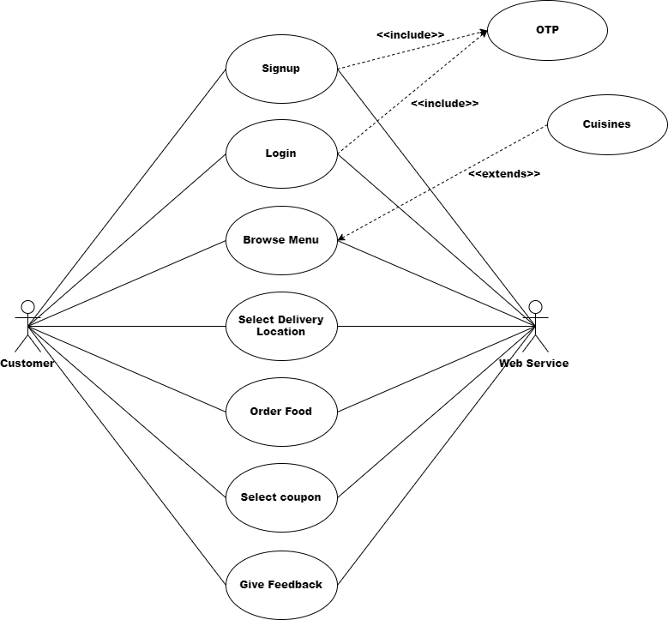

### 4.1.2 Admin

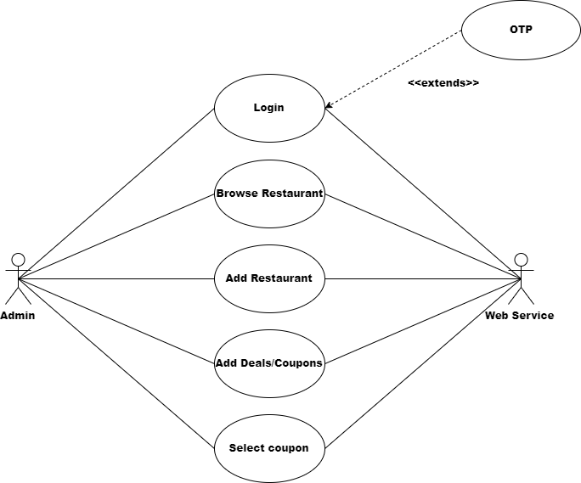

### 4.1.3 Manager

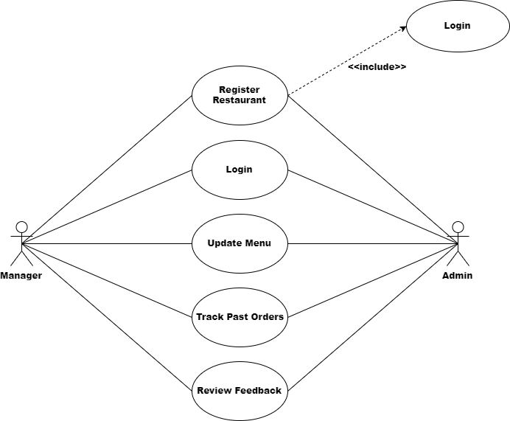

### 4.2 Activity Diagram

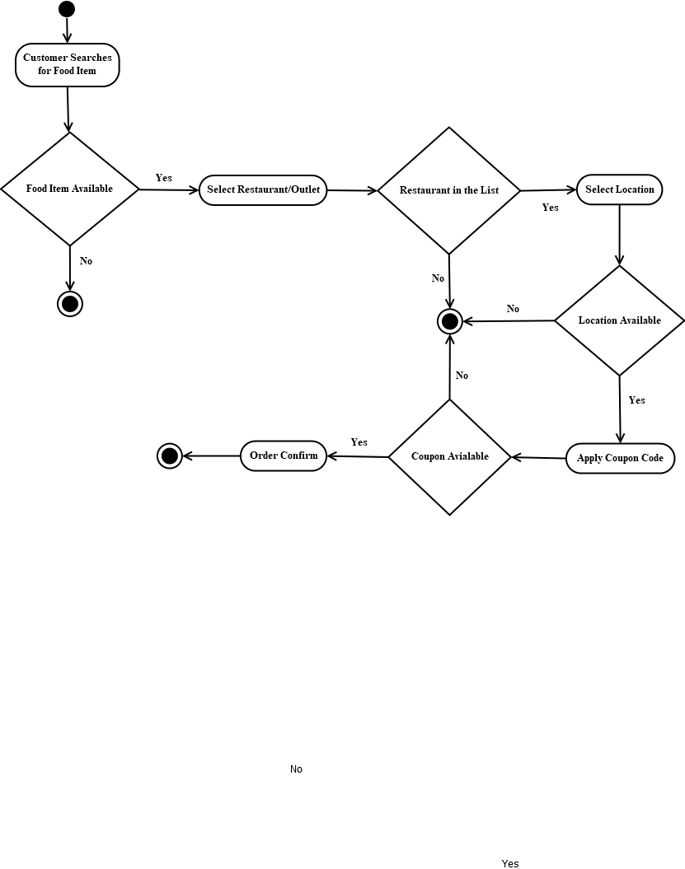

### 4.3 Class Diagram

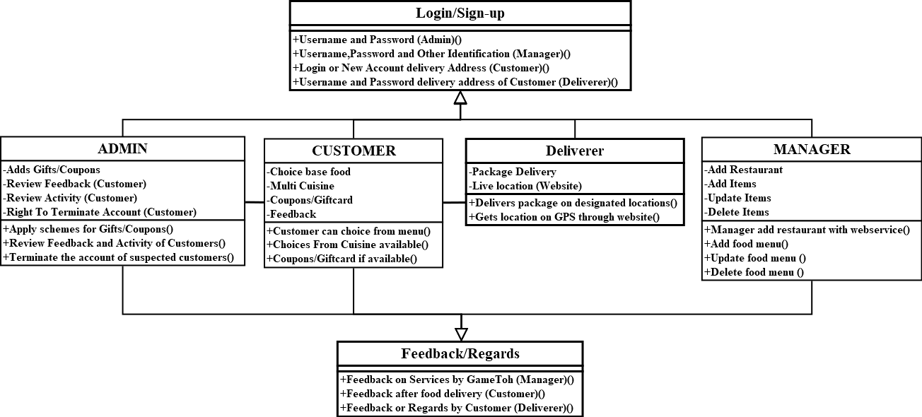

## 4.4 Interaction Diagram

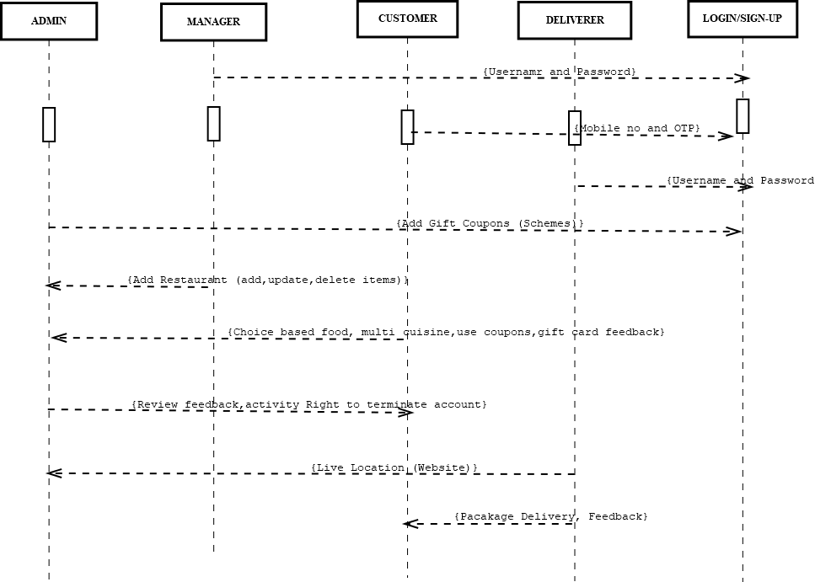

## 4.5 Data Dictionary Diagram

### 4.5.1 Customer Data Dictionary Diagram:

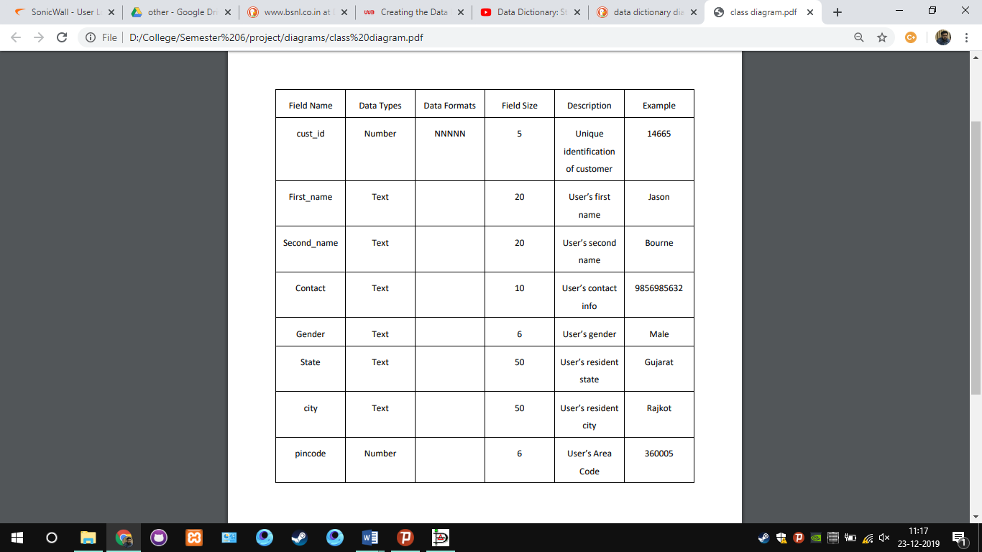

### 4.5.2 Restaurant Data Dictionary Diagram

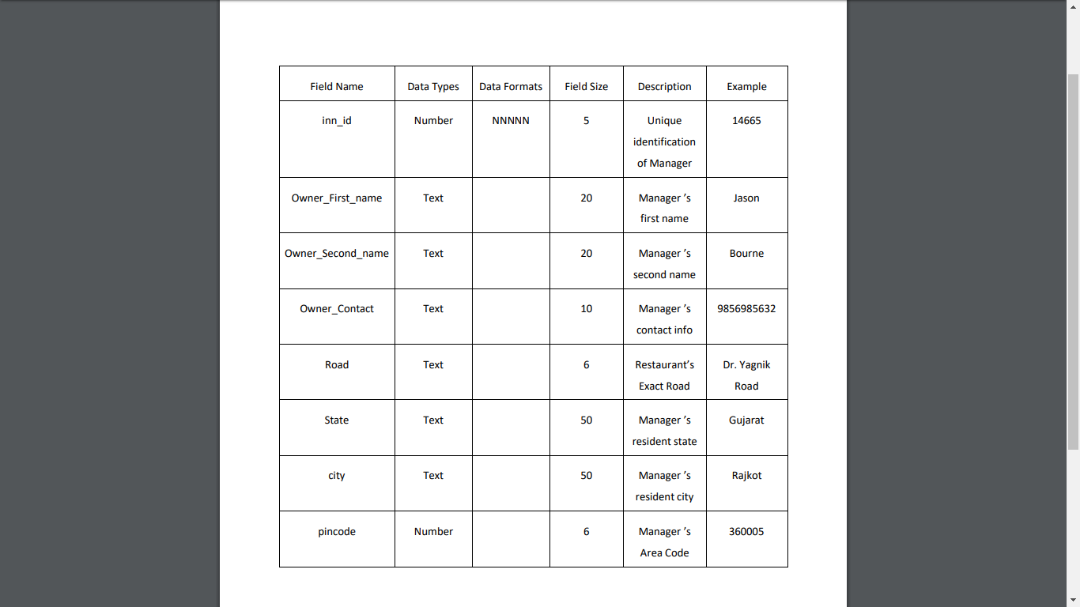

# 5 System Testing

**5.1 Login**

|  |  |
| --- | --- |
| Page | Login |
| Description | It is a common login page which lets user enter in |
| Input | Username and Password |
| Output | Successful Login |

**5.2 Homepage**

|  |  |
| --- | --- |
| Page | Homepage |
| Description | Users can view hotels and place their food order |
| Input | Select food items from menu available |
| Output | Placing Order |

**5.3 Admin Controls**

|  |  |
| --- | --- |
| Page | Admin Login |
| Description | System admin can view restaurants, verify new ones, view customers, view monthly sales etc. |
| Input | Admin credentials |
| Output | Admin Dashboard |

# 6. Screenshots

**6.1 List new restaurant on the website**

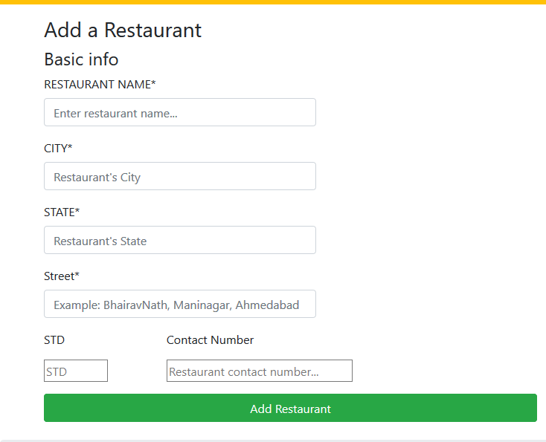

**6.2 Customer Login and Search Restaurants**

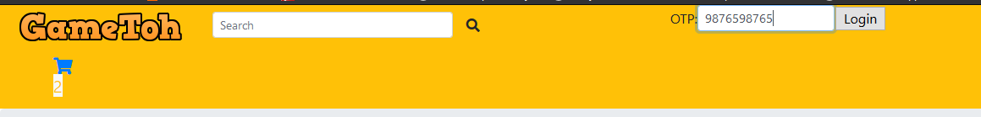

**6.3 Add to cart**

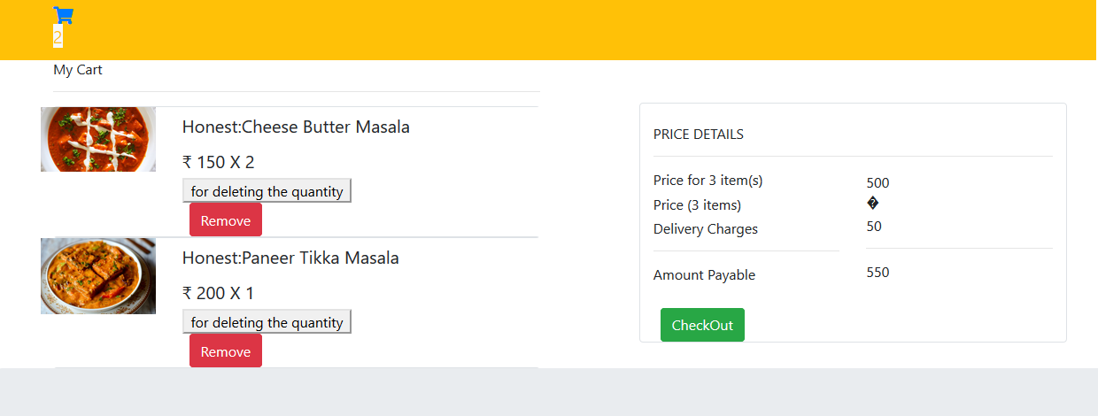

**6.4 Checkout**

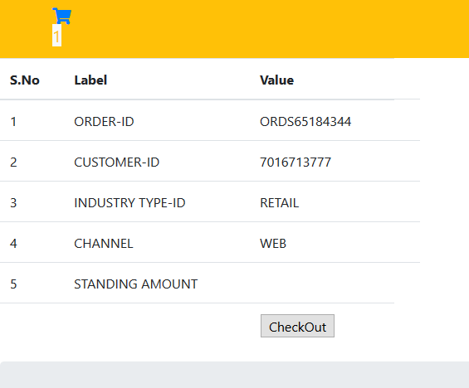

**6.5 Redirecting to payment**

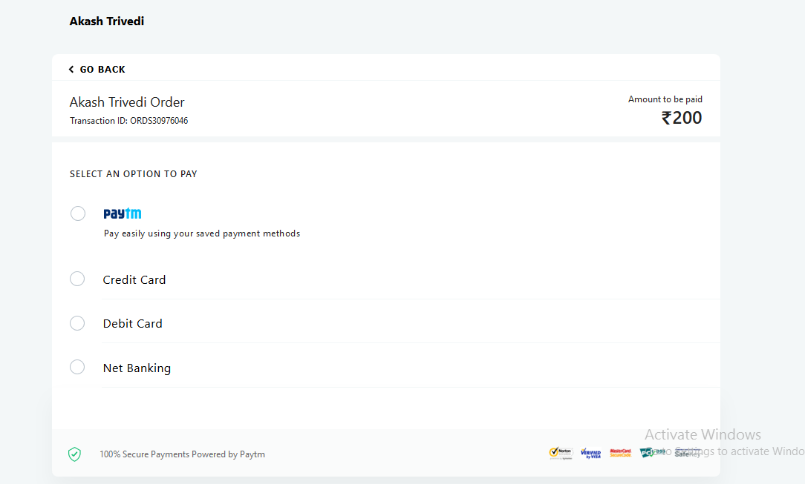

**6.6 Admin side**

**6.6.1 Admin Login**

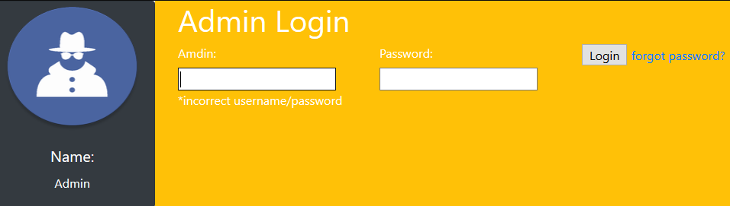

**6.6.2 Monthly Sales**

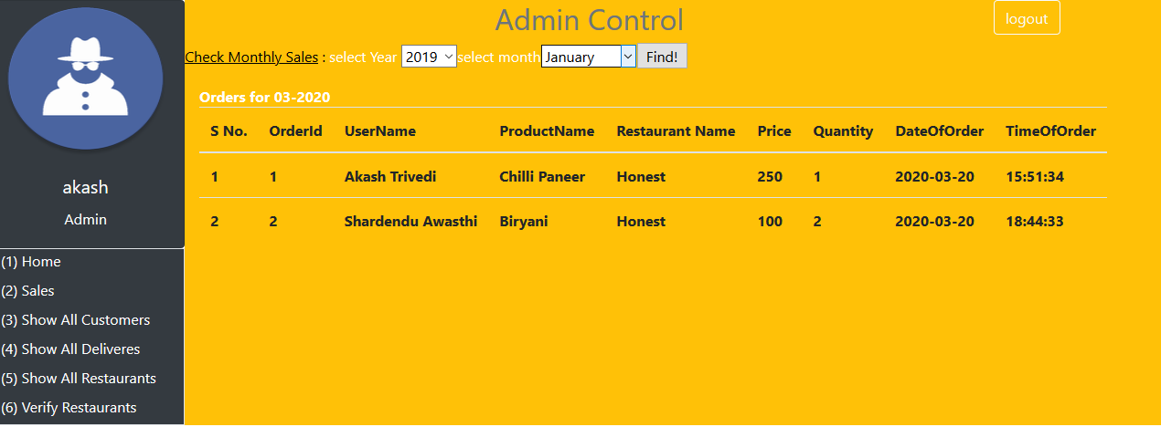

**6.6.3 List customers**

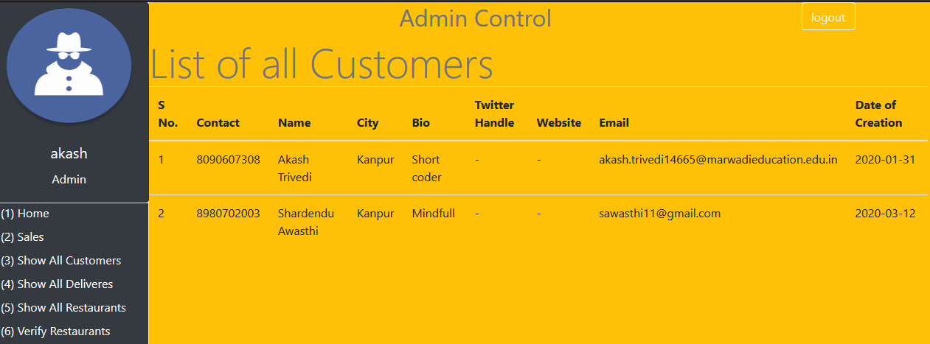

**6.6.4 List restaurants**

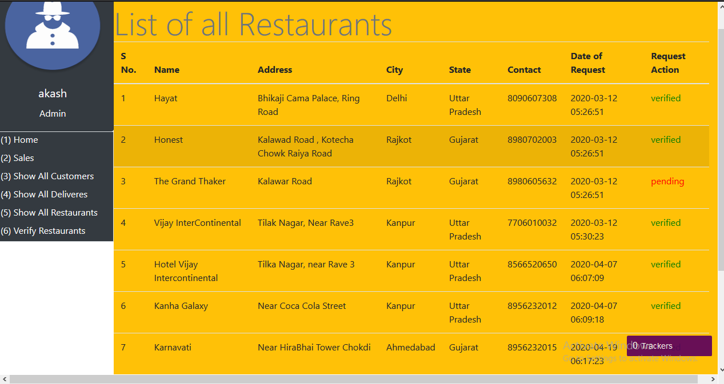

**6.6.5 Verify new restaurants**

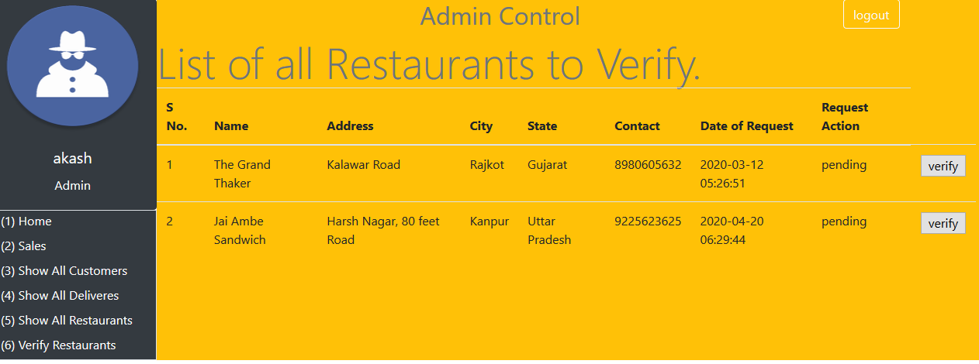

# Source-Code

**Head.php**

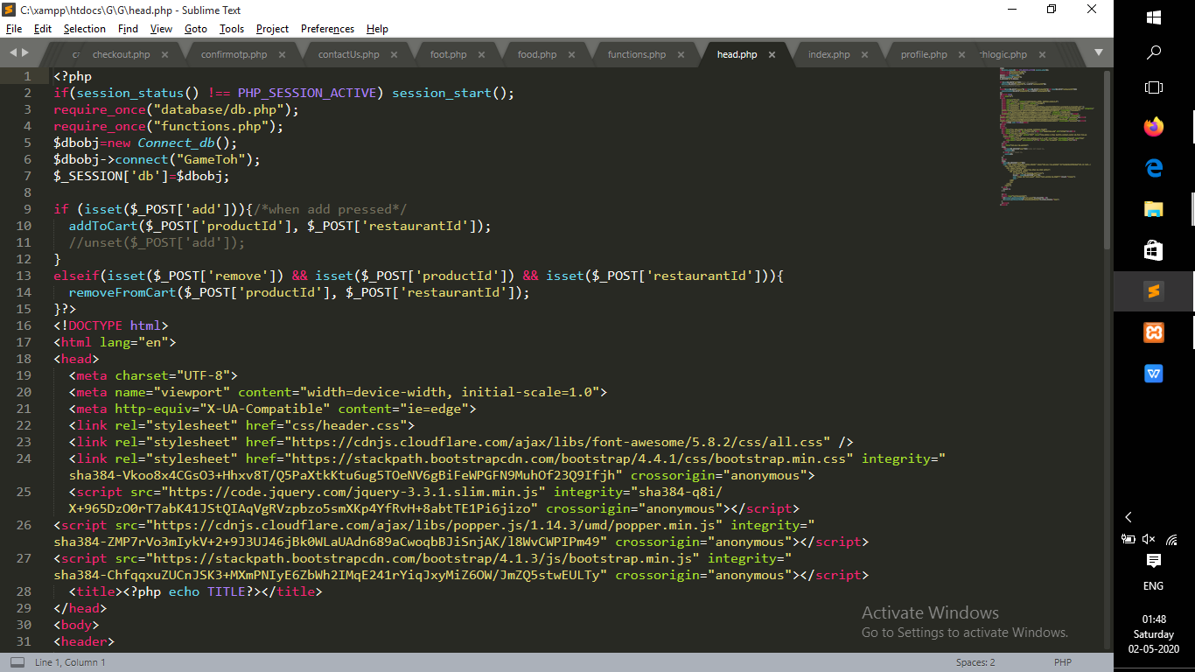

**Add_Restaurant.php**

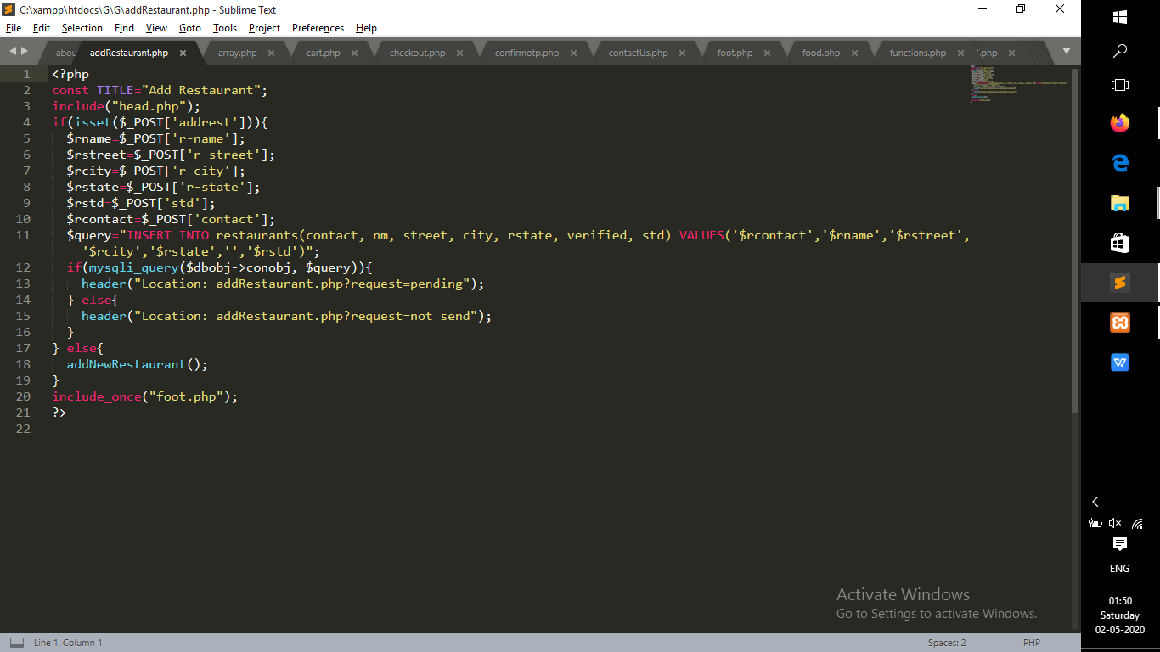

**Cart.php**

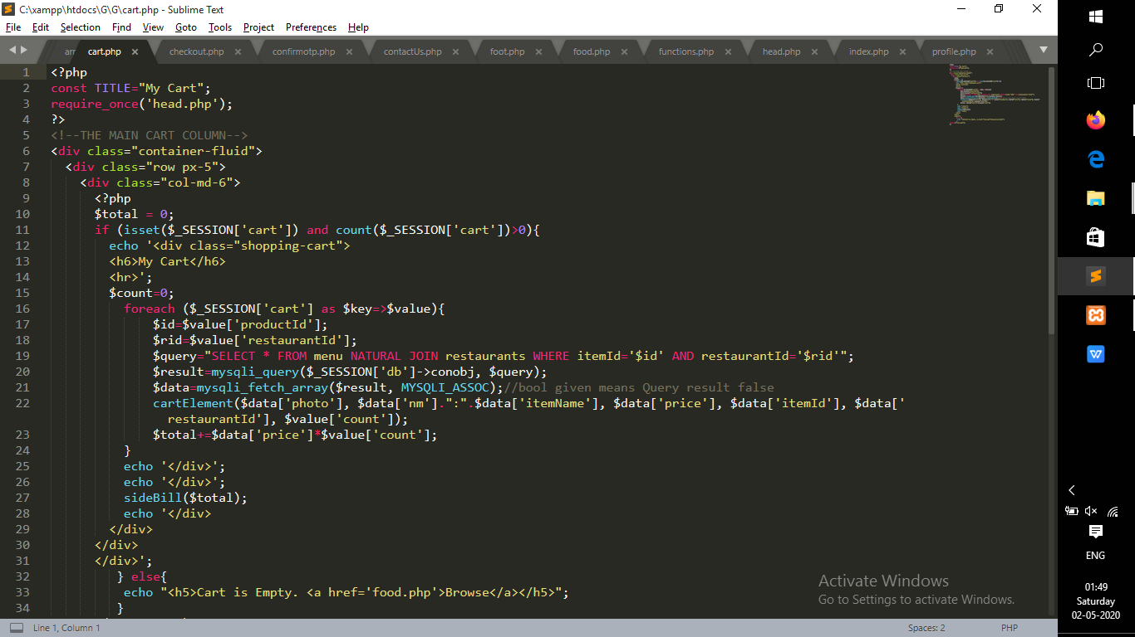

**Checkout.php**

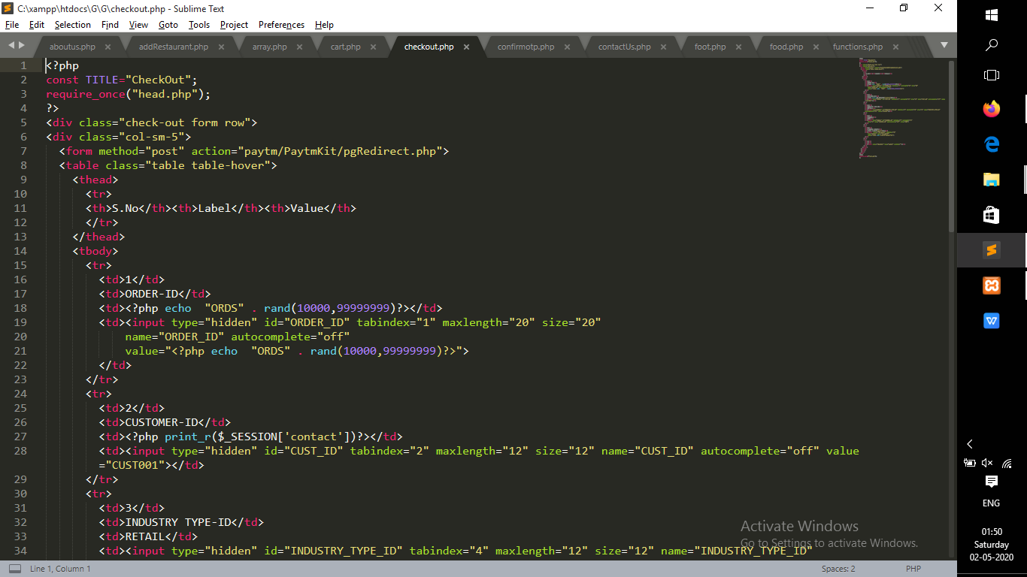

**Food.php**

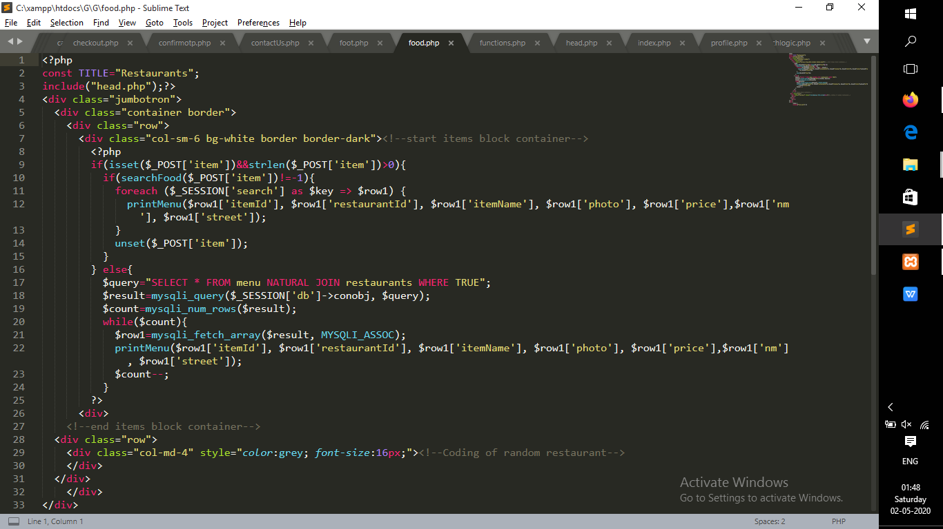

**Add-To-Cart.php**

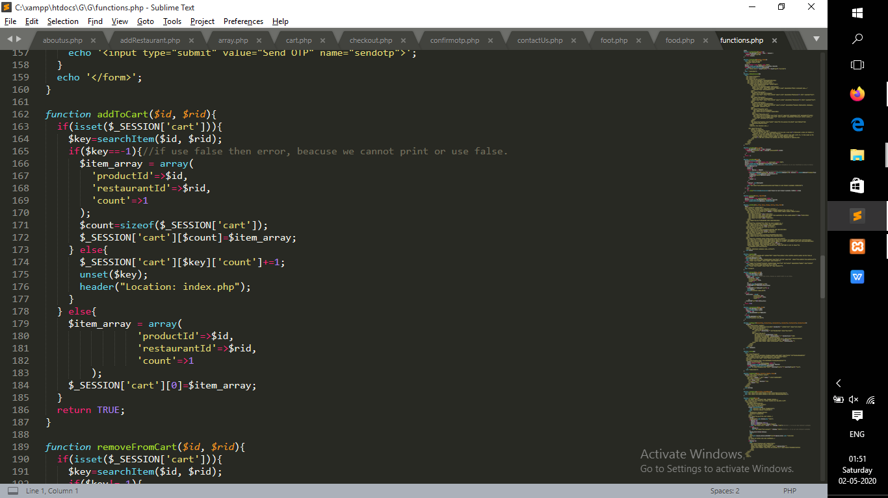

**Remove-From-Cart.php**

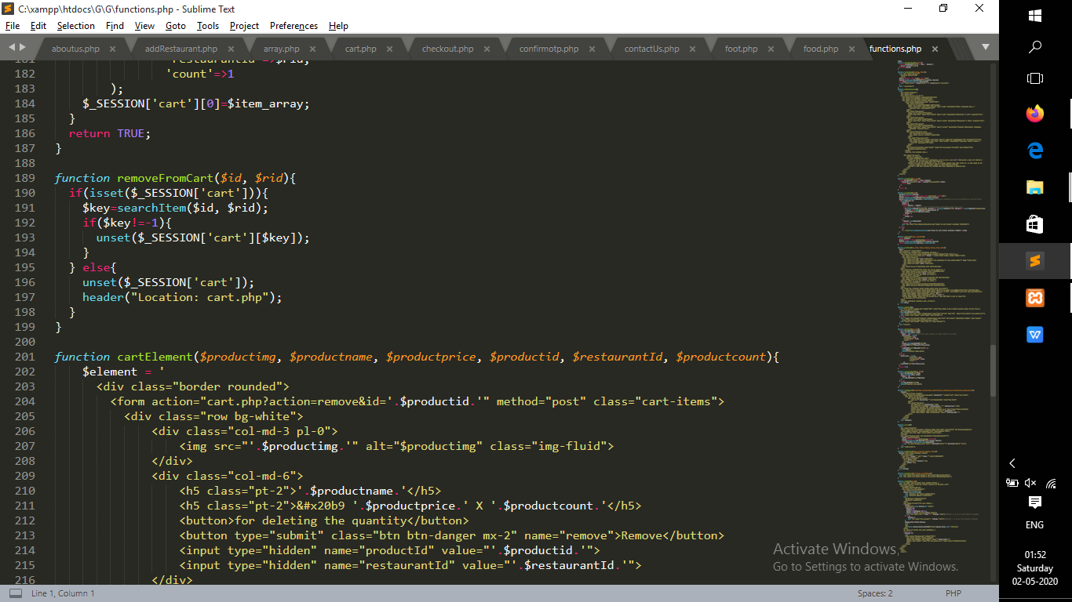

**Search-Food.php**

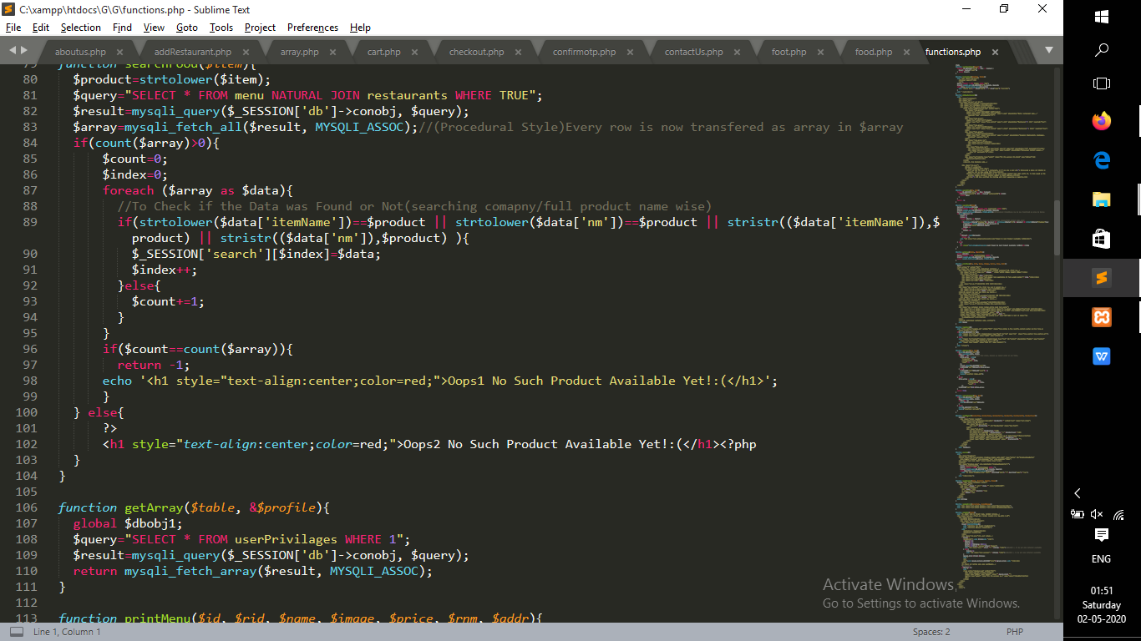

**Billing.php**

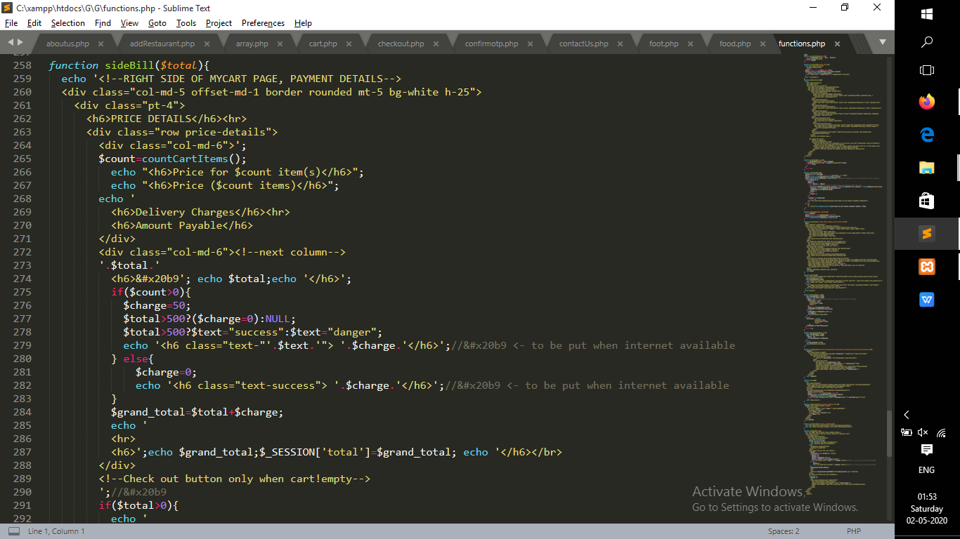

**UserLogs.php**

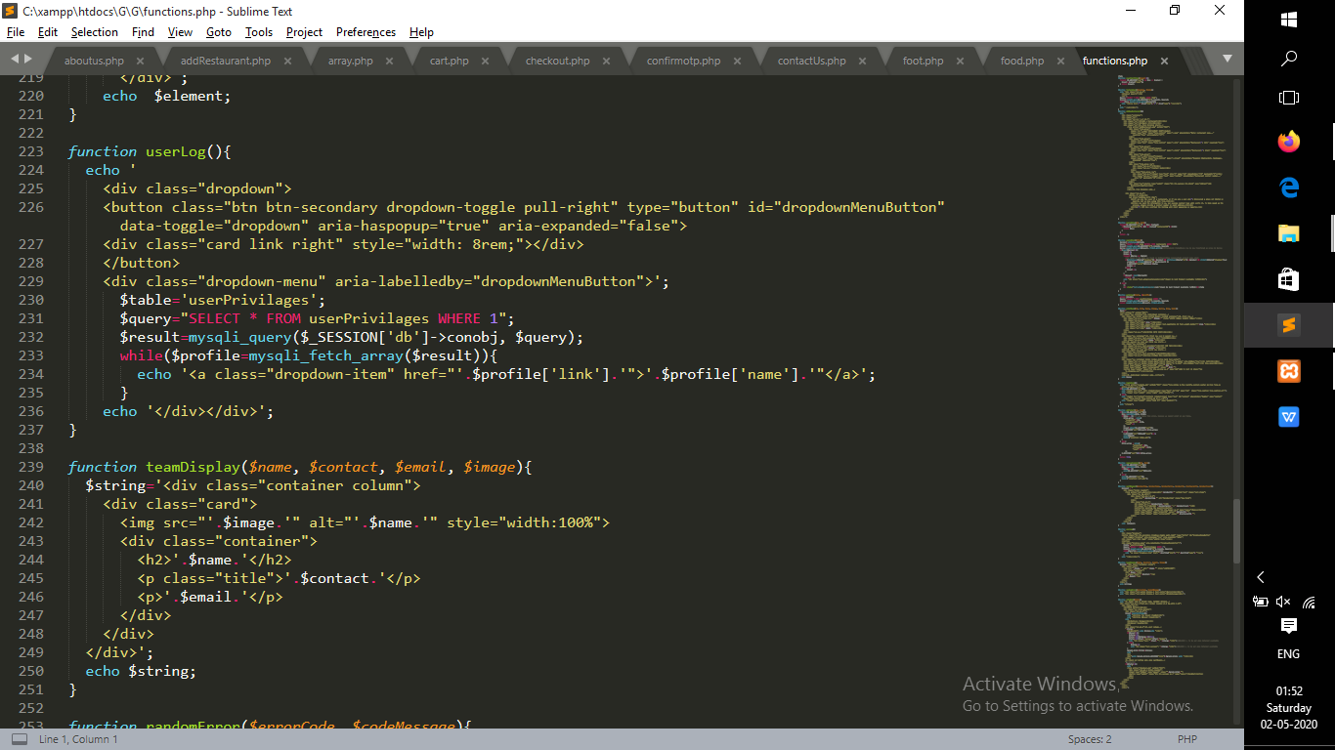

**Search-Logic.php**

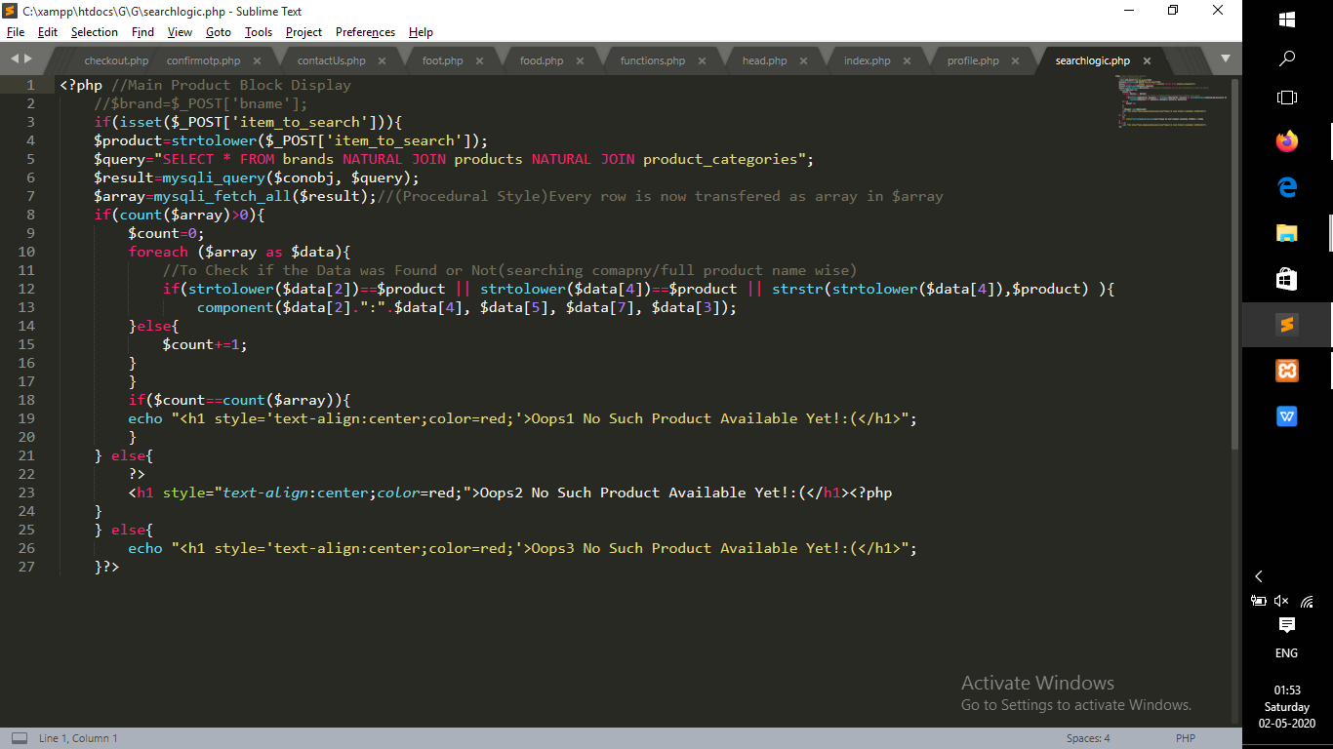

# 8. CONCLUSION

At the end of our project we are conclude that our project is error free and all the modules run successfully and all its operation are also perfectly performing its Corresponding work.

Also we mentioned that our project is used for using our food delivery service related to Edible Items only. We in future are trying to reach out every Person’s need and add as many restaurant we can reach.

We want to grow this Network around India and Provide India a better and fast at home service.

Online Food Ordering system is developed on the basis of user's requirements. This system is based on solving one of the common problems of everyday life. It gives information needed in making food orders.

Customers can order any food as per their convenience. The system made for restaurant can help receiving orders and modifying its data. Also admin has control over the system. With online food ordering system, a restaurant can upload their menu online and customers can easily place order. Orders can be tracked easily. Food delivery service can be improved as maintenance of customer's database is done. The restaurants can even customize online restaurant menu.

Potential customers can easily access menu and place order. Hence, an automated food ordering system is presented with features of wireless communication. As more and more people are migrating to urban cities, they can avail this benefit of food services at any period of time. As food are brought to the doorstep, the unnecessary transportation will be reduced and thereby pollution will be decreased.

# BIBLIOGRAPHY

## ONLINE REFERENCES

* <https://www.w3schools.org/css>
* <https://www.w3schools.org/html>
* <https://www.w3schools.org/php>
* <https://www.w3schools.org/bootstrap>
* <https://www.php.net>

## OFFLINE REFERENCES

* HTML Black Book
* Teach Yourself Php
* JavaScript Cook Book